Assignment -4

Docker and Kubernetes

|  |  |
| --- | --- |
| Assignment Date | 26 October 2022 |
| Student Name | Kaviyarasan B |
| Student Roll Number | 713319EC507 |
| Maximum Marks | 2 Marks |

1.Pull an image from docker hub and run it in docker Playground

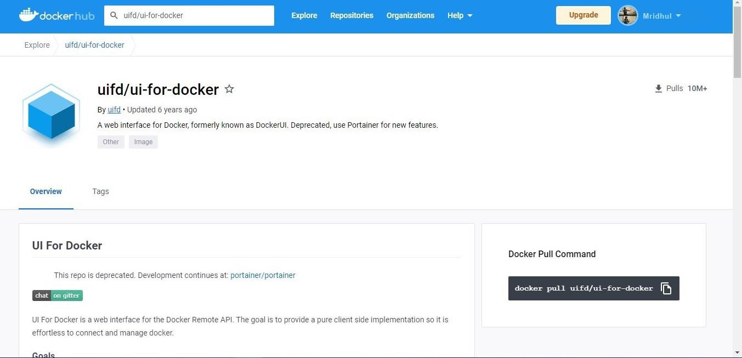

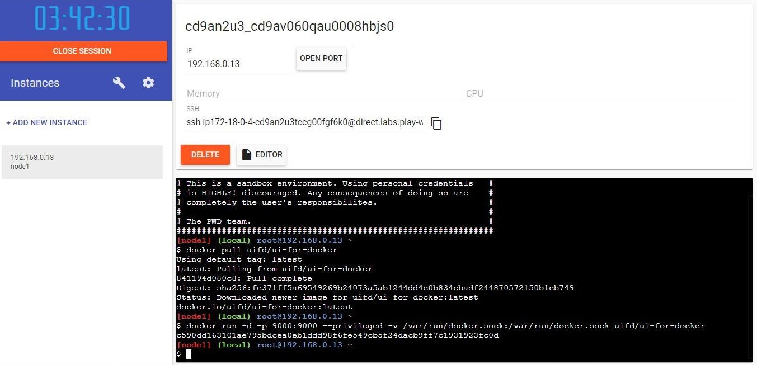

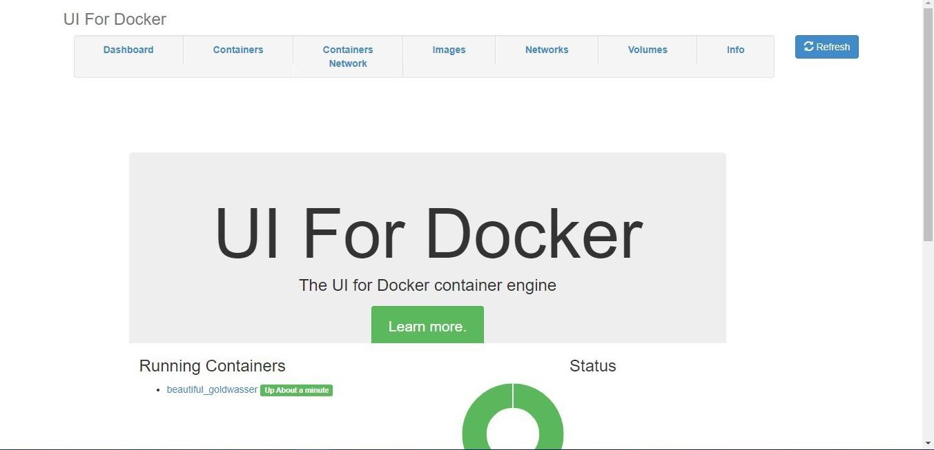

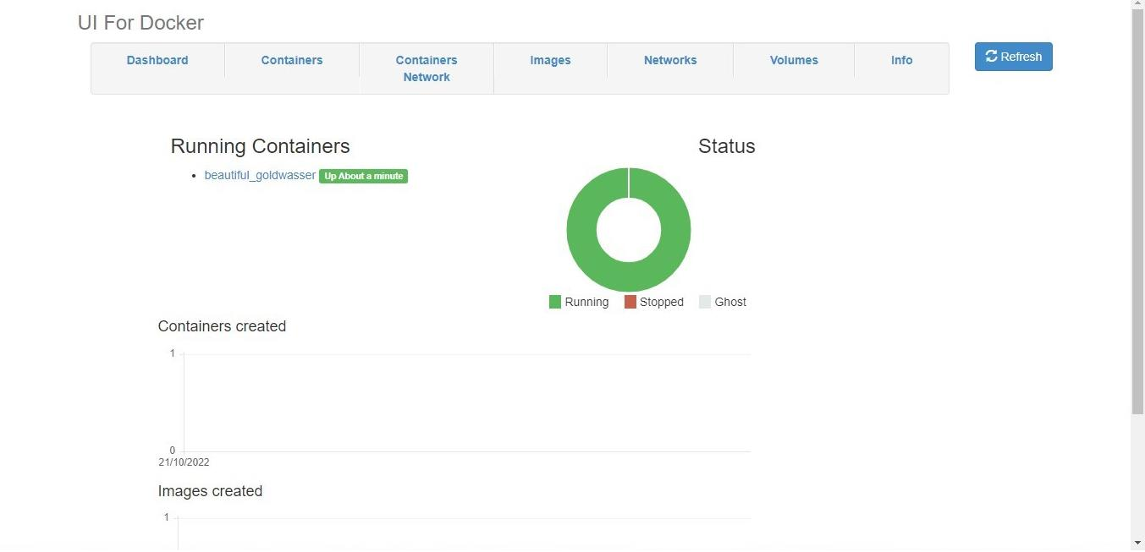

2.Create a docker file for the job portal application and deploy it in Docker desktop application

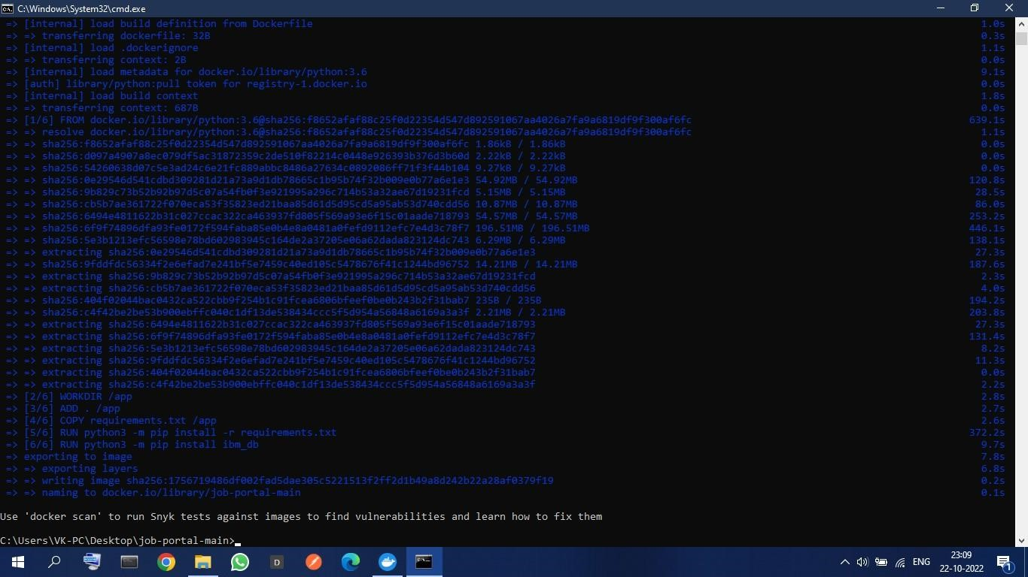

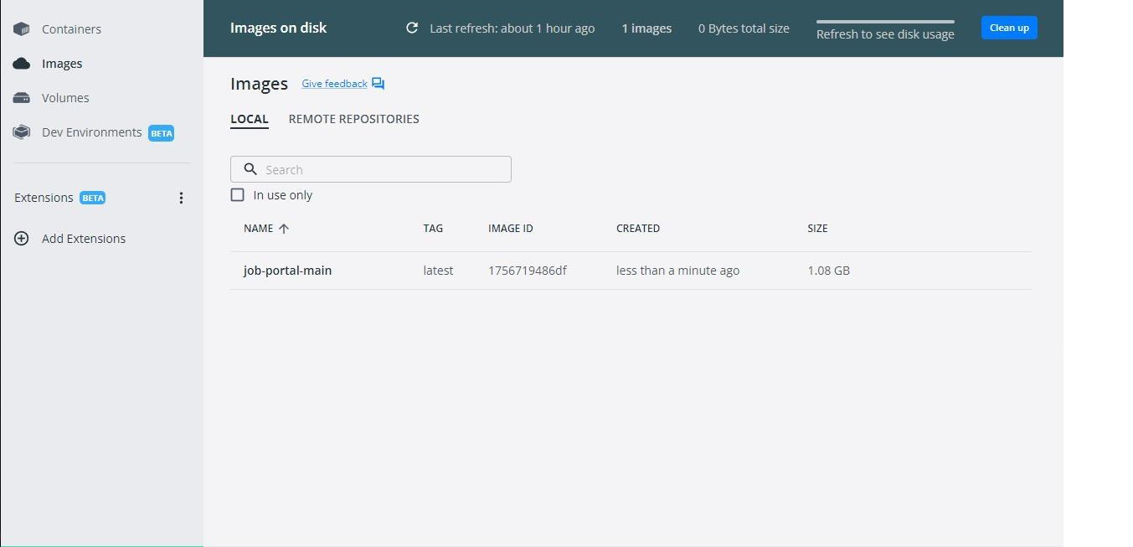

3.Create a IBM container registry and deploy helloword app